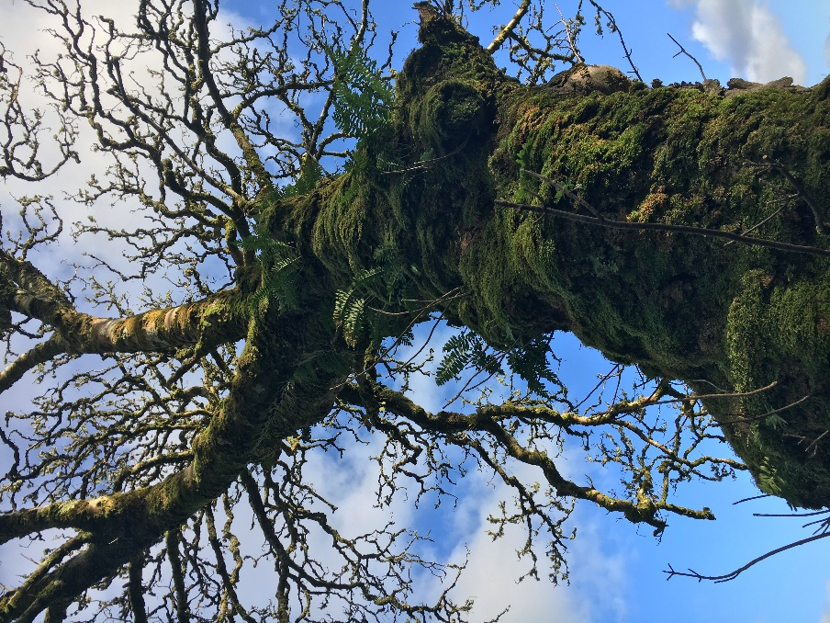
Serpent and the Veil: A Mystery School of Indigenous Celtic Wisdom
Purpose: Designed in keeping with ancient mystery schools of Europe, to initiate participants into spiritual and mystical connection with the ancient wisdom of Ireland, in order to walk through the veil to heal and transform self, community and Earth, to awaken the serpent within and without.
The School:
Join me for an in-depth immersion of a year and a day, in the tradition of our ancient mystery schools in Europe, to connect to the spiral dance of life, to participate, remember and embody the rhythms of the season and the powers found within and without. We will reclaim our sense of belonging and our own sovereignty through Irish Celtic myths, the land herself, indigenous herbs and sacred ritual. We will traverse through the veil and collectively work to reconnect the Otherworld with our own, thus restoring balance and healing to the Earth.
Through Serpent and the Veil mystery school, you will be initiated into spiritual and mystical connection with our Irish heritage in order to walk through the veil to heal and transform self, community and Earth.
Through Serpent and the Veil mystery school we will gather in community and, through that power, destabilize the reach of the patriarchy. One ritual, one circle, one myth at a time.
Through Serpent and the Veil we will work with herbs and their wisdom, accessing primal connections and the knowing held within and without. We will experience the oneness that we all are through the culmination of accessing entheogenic aspects of the most sacred plants.
Through Serpent and the Veil we will live with the seasons, celebrate the eight sacred festivals, connect with lunar cycles and, through that, discover our place of belonging in the cosmic rhythm.
Through Serpent and the Veil we will shed the culturalized layer of skin, the consumeristic, capitalistic skin that has held us captive, and through that shedding we will rise into our own sovereignty of participation and protection, the serpent awakened.
Many of us that are not BIPOC (Black, Indigenous, People of Color) in America come from Native European roots. The Serpent and the Veil allows us to reclaim our own traditions and roots, shifting from the appropriation of spiritual traditions that are not our own. Many of us in the United States/ America have Native European heritage and this school is meant to help us learn, remember and practice our own rituals. This school is not meant to be exclusive in any way. All are welcome to receive and use the tools to deepen into their own traditions. Listen to the voice of your own knowing to discern if this is the right program for you. Please do not base your decision on the outcome of an ancestry DNA test, as that is giving your power to the patriarchy and discounting the knowing and longing in your own heart. (And there is increasing controversy around the accuracy of these tests and how they are being used). All are welcome.
In Serpent and the Veil, we will be:
- Calling in the Ancestors
- Working with Gods and Goddesses of the Tuatha de Danaan including Lugh, Brighid and the Morrigan as our patrons, plus many others
- Reading Irish mythology and discussing and practicing its relevance and purpose in our lives today
- Using guided journeywork to connect and journey through the Veil to the Otherworld
- Celebrating rituals aligned with the seasons
- Working with the ancient symbolism of tarot
- Allying with indigenous Irish herbs
- Connecting with lunar wisdom
- Pilgrimaging on the sacred land of Ireland
- Sharing our gifts with the greater community
- Creating art to deepen in to our experience

Students who engage in this mystery school journey will be:
- Curious and open
- Willing to journey to the wild edges, willing to sacrifice fear for growth
- Committed to the financial exchange
- Questioning
- Deep listeners
- Comfortable with nonlinear thinking
- Disciplined
- Playful
- Embodied

DATES:
Samhain 2018- Samhain 2019
One Saturday per month from 10AM- 4PM for coursework and 6PM- 9PM for ritual and guided journeywork in Denver Colorado PLUS eight Friday evenings from 6PM- 9 PM to align with the sacred festivals of the Wheel of the Year
NOVEMBER: Fri Nov 2 from 6-9 Samhain and Sat Nov 3 10-4/ 6-9
DECEMBER: Sat Dec 1 from 10-4/ 6-9 and Fri Dec 21 6-9 Winter Solstice
JANUARY: Sat Jan 5 from 10-4/ 6-9
FEBRUARY: Fri Feb 1 from 6-9 Imbolc and Sat Feb 2 10-4/ 6-9
MARCH: Sat March 2 10-4 6-9 and Fri Mar 22 6-9 Spring Equinox
APRIL: Sat April 6 10-4/ 6-9
MAY: Sat May 11 10-4/6-9 and Sat May 17 6-9 Lunar Beltaine
JUNE: Sat June 1 10-4/ 6-9 and Fri June 21 6-9 Summer Solstice
JULY: No class: IDIR AIT (the in-between)
AUGUST: Fri August 2 6-9 Lughnasa and Sat August 10 10-4 and 6-9
SEPTEMBER Sat Sept 7 10-4/ 6-9 and Fri Sept 20 6-9 Autumn Equinox
OCTOBER/ NOVEMBER: Ireland Pilgrimage: Sun Oct 27- Sun Nov 3
A year and a day, we will journey together.

Distance students can be accommodated if the following are met:
- Travel to Denver for three of the classes (a combination of Friday and Saturday participation)
- All classes will be available via recorded unedited audio, sent within 2 days of the class, or students can join via live video call (video will not be recorded)
- All other requirements of the course

CURRICULUM/ REQUIREMENTS FOR INITIATION
Students will eligible for initiation, during the pilgrimage in Ireland by completing:
- Reading list (6-9 books to be read/ referenced). All students must supply their own books plus a Centennial Tarot Deck
- Community engagement: service work/ offerings in and to the community (20 hours over the year)
- Completion of ritual tools for altar
- Herbal alchemy project (herbal formulas)
- Soul cards for 10 of the myths that will be covered in class (simple collage art)
- Attendance at 90% of the classes/ rituals (in person or virtual)
Opportunity to participate in a ritual engaging indigenous entheogenic herbs during the pilgrimage in Ireland (optional)
All details will be provided at the beginning of the course.
Students should plan on 10+ hours outside of class for completion of projects, reading etc. each month.

PRICE:
$3,920 including 12 monthly installments of $285 (taken automatically from a credit card each month) and a $500 non-refundable deposit to hold your spot. $500 non-refundable deposit is due upon registration.
Includes all materials (with the exception of the book list readings and tarot deck), mystery school teachings, ritual and journeywork and a seven day pilgrimage to Ireland (Includes lodging, two meals per day, transportation within Ireland, guides and entry fees. Does Not include airfare or one meal per day during the pilgrimage.).

Offered by:
Tonja Reichley, Herbalist (Bsc, MBA), Ritualist and Author, has been teaching herbal classes rooted in Irish traditions, healing and spirituality for 15 years. She has lived part time on the west coast of Ireland for 12 years, continually learning from the land, the plants, the people and the Ancestors as well as her teacher Gina McGarry, whom she studied with in a three-month immersion in 2001, in residence in Ireland. She graduated from the Rocky Mountain Center of Botanical Studies in 2000, began her first herbal business, MoonDance Botanicals, in 2002. She opened a store-front in Denver Colorado in 2004, had a thriving herbal business for many years and sold it to long-time customers in 2016 and it is still a cornerstone of the herbal scene in Denver and beyond.
Tonja has lead sacred journeys to Ireland for 12 years and continues to do so, including a two week Herb School and two pilgrimages per year. In 2017 she published Wild Irish Roots: A Seasonal Guidebook to Herbs, Ritual and Connection and her Way of Brighid Oracle Cards have been selling worldwide for many years.
Website: dancingwiththewild.com
Instagram: @tonjareichley
Facebook: Dancing with the Wild
Email: tonjareichley@gmail.com

